Name : Saurabh Sanjay Jadhav

Topic : Jenkins user creation and triggers

Assignment no : 21

1. We can create groups of builds.

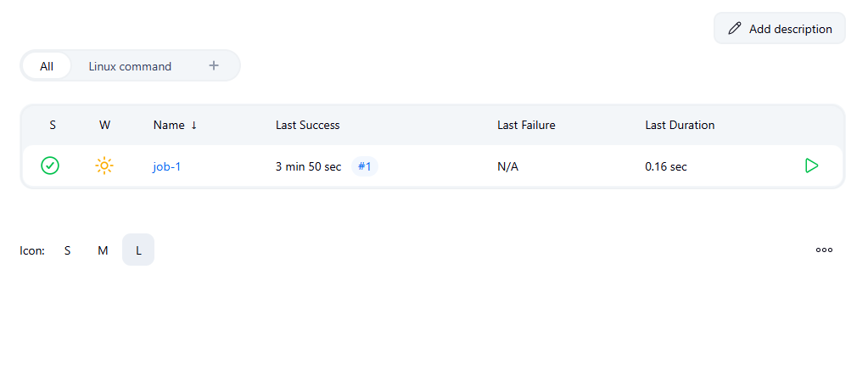

1. Jenkins trigger :
2. Build after other projects are build.

Create a project to clone public repo

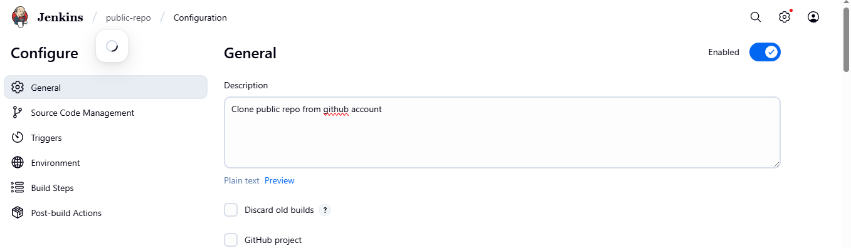

Provide the git repo link

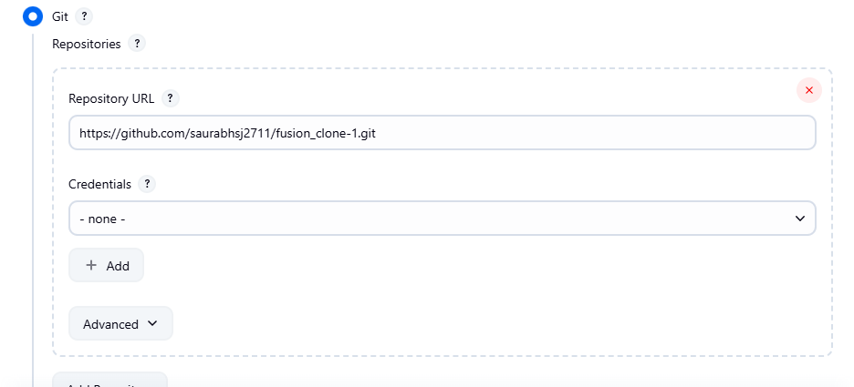

Select the project that needs to be build before current project.

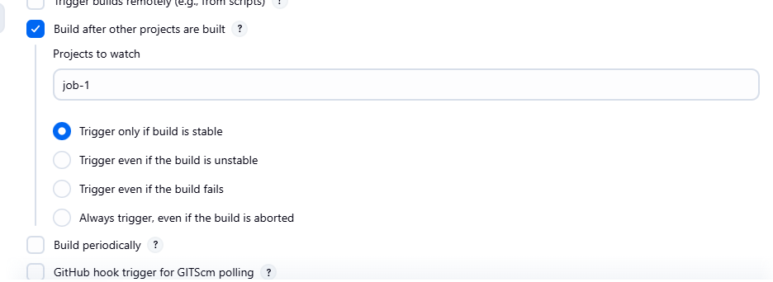

When we build the job-1 project then automatically pub-repo project will build.

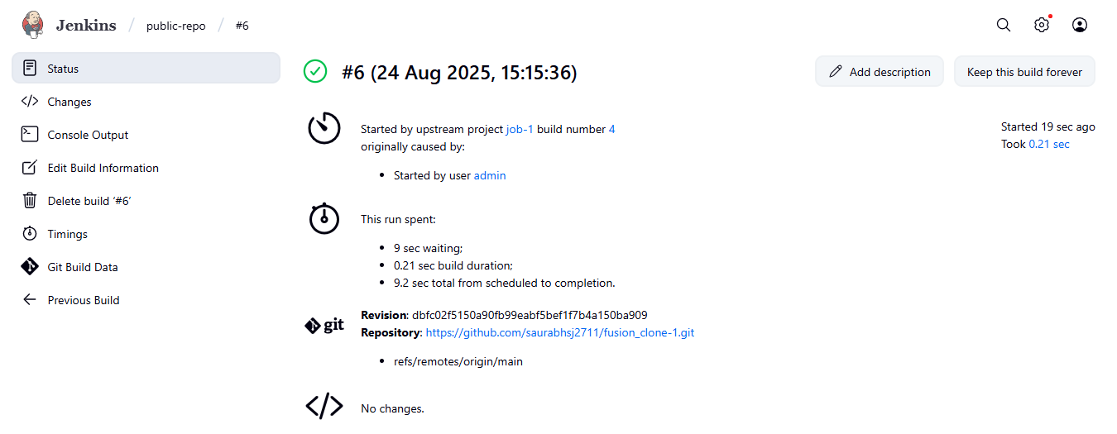

1. Build periodically

Create new project

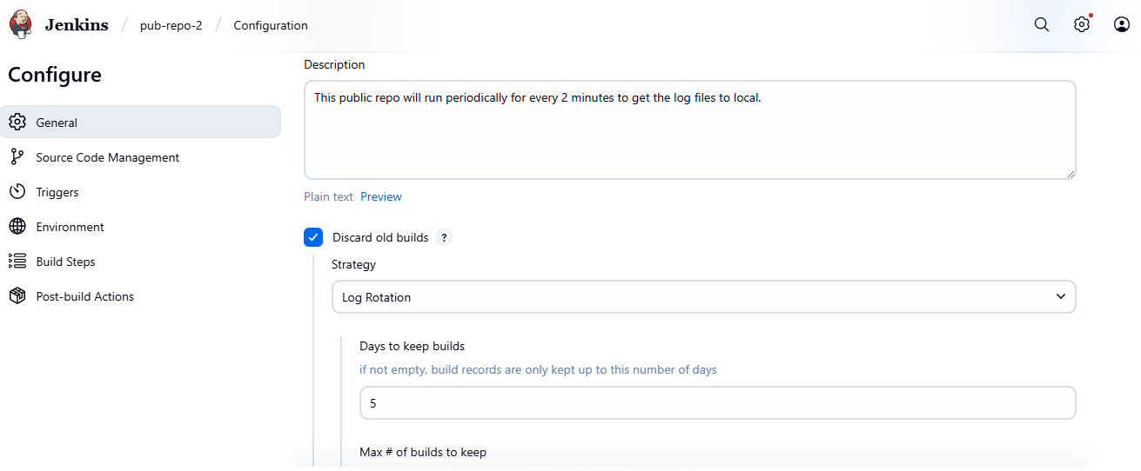

Provide Git repo link

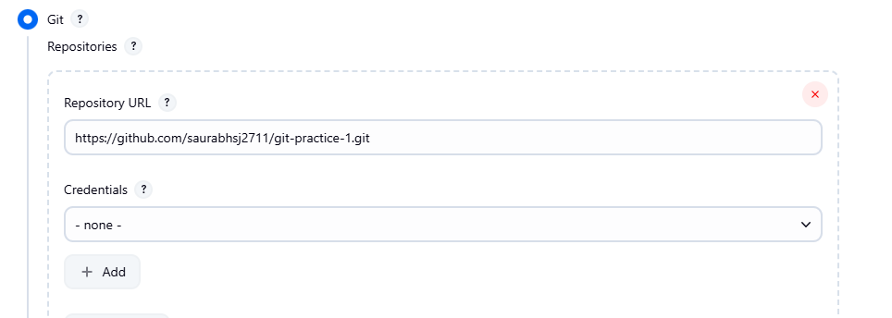

Provide trigger of build periodically for every 2 mins.

Minutes(0-59) hours(0-23) day of month(1-31) month(1-12) day of week(0-6)

H/2 \* \* \* \*

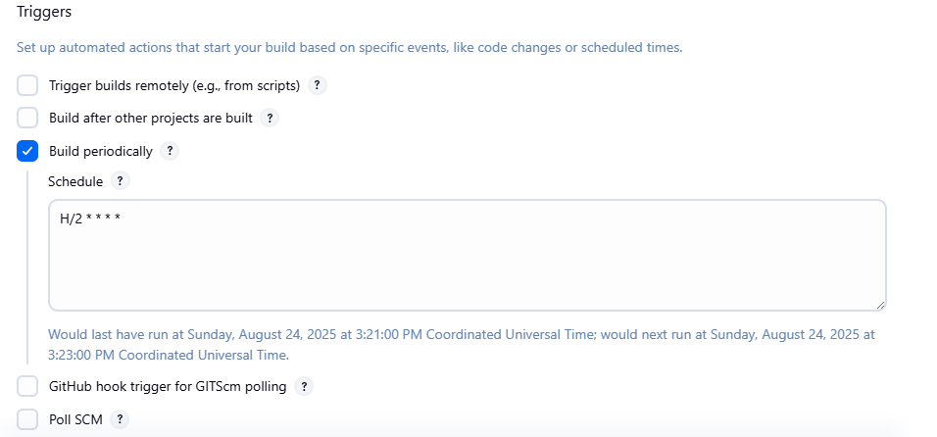

1st build

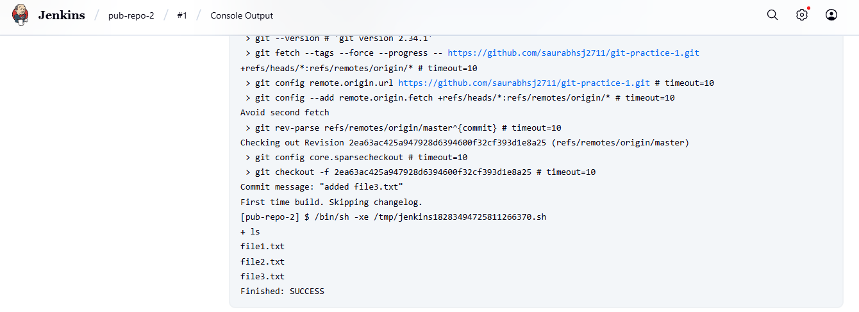

Automaticaaly 2nd build takes place

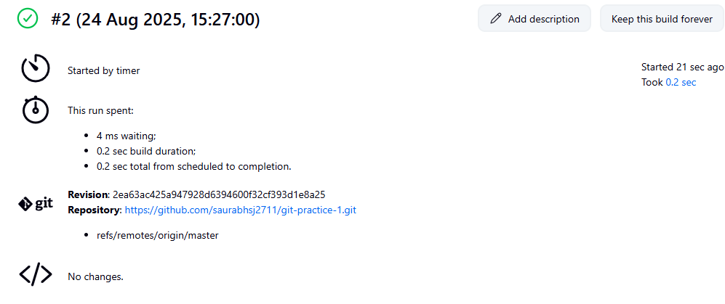

3rd build.

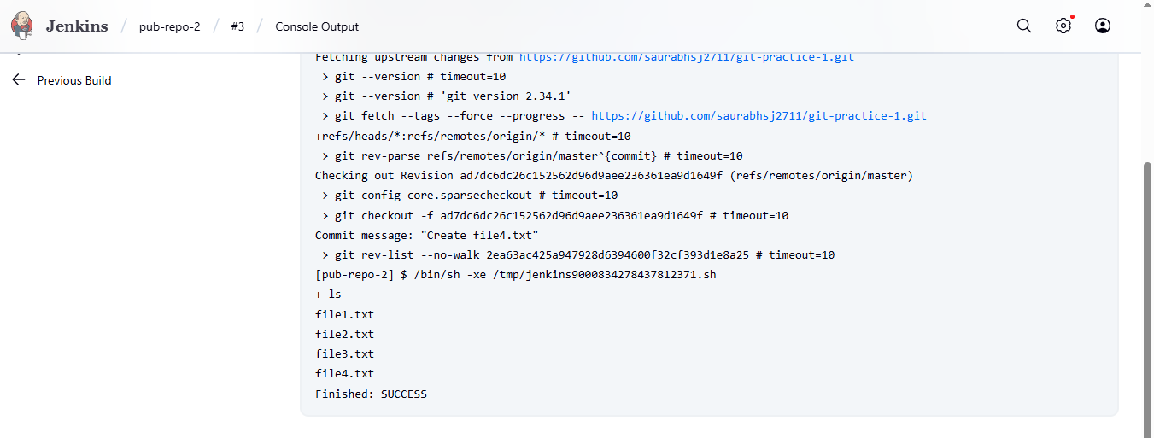

1. Poll SCM : It will build the project if there are any changes to it and build it on schedule provided.

Just changes the trigger in previous project to Poll SCM.

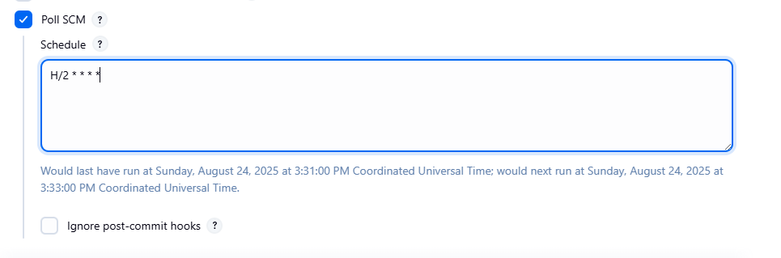

In 3rd build it contains 4 files.

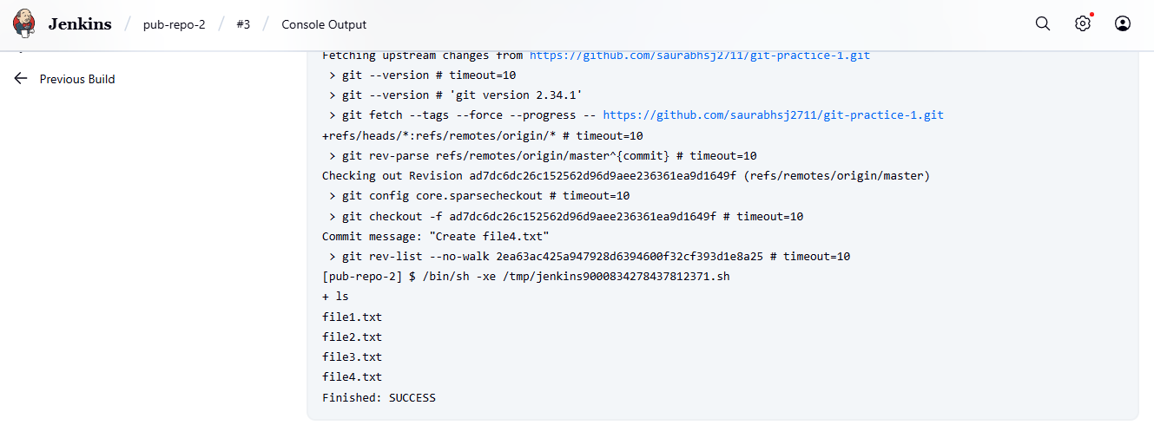

Added the 5th file to repo

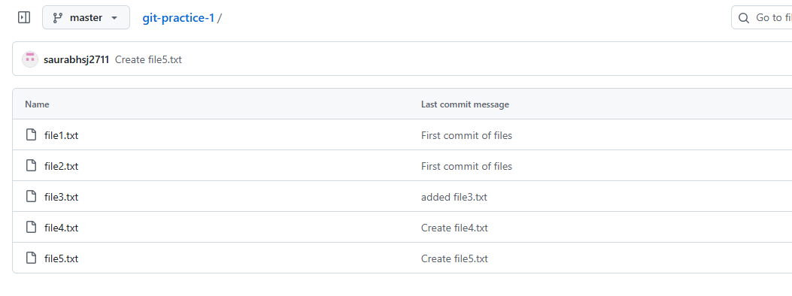

4th build took place and 5th file is added to workspace.

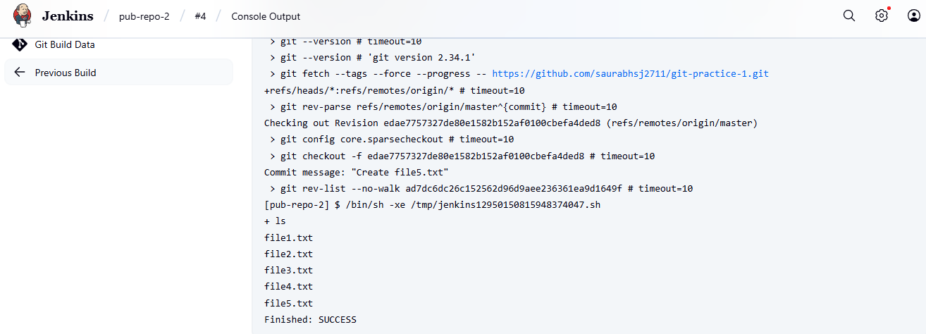

1. User creation and access assignment to user.
2. Create user. Under manage Jenkins select user tab.

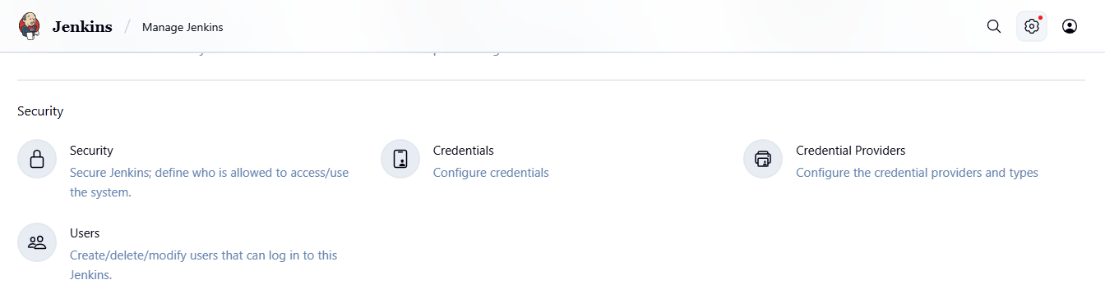

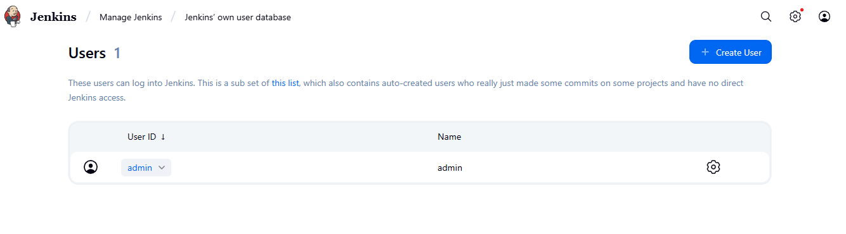

1. Provide user details

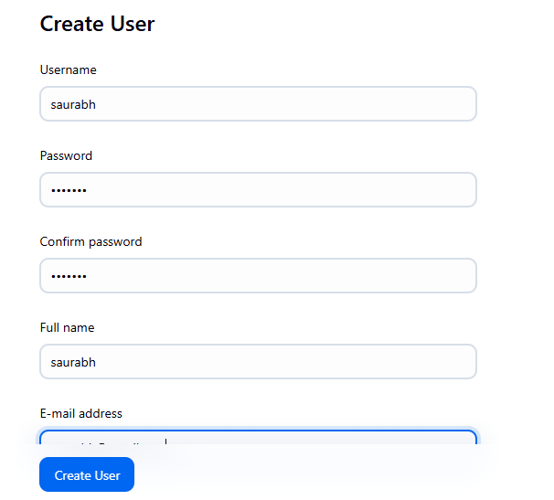

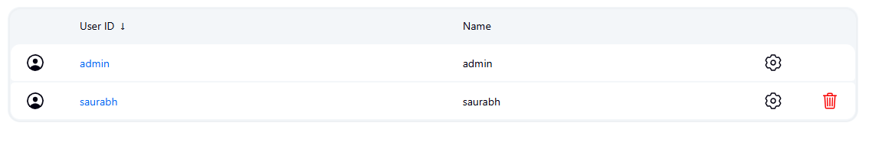

Signed in as Saurabh user

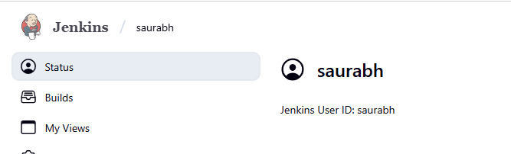

1. Allow user to register.

Under Manage Jenkins -🡪 Security 🡪check “Allow user to sign up”

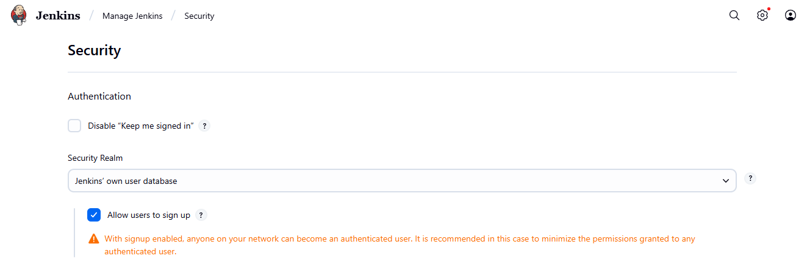

Register option is available on homepage

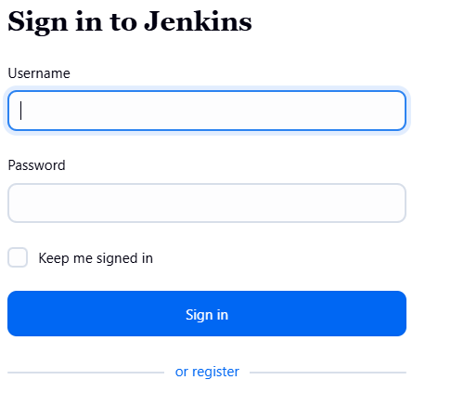

Provide user details for registering users.

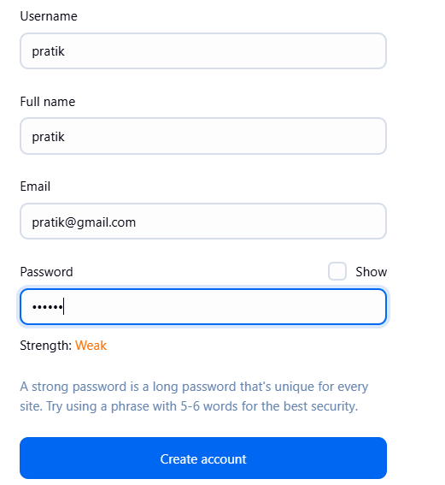

Successfully logged in as Pratik

